A context is the imagined situation students enter and explore each time you use one of the keys. The context you use frames the curriculum and makes learning meaningful and purposeful for students to engage with. A context is made up of six elements:

* Characters – people, animals or other living things

involved in the situation

* Location – the place or places where the situation

is happening

* Events – the action, or things going on in the situation

* Time – the time of day, season, or period in history when

the situation is happening

* Tension – a sense of peril, suspense, or other importance

within the situation

* Focus – the main point of interest within the situation

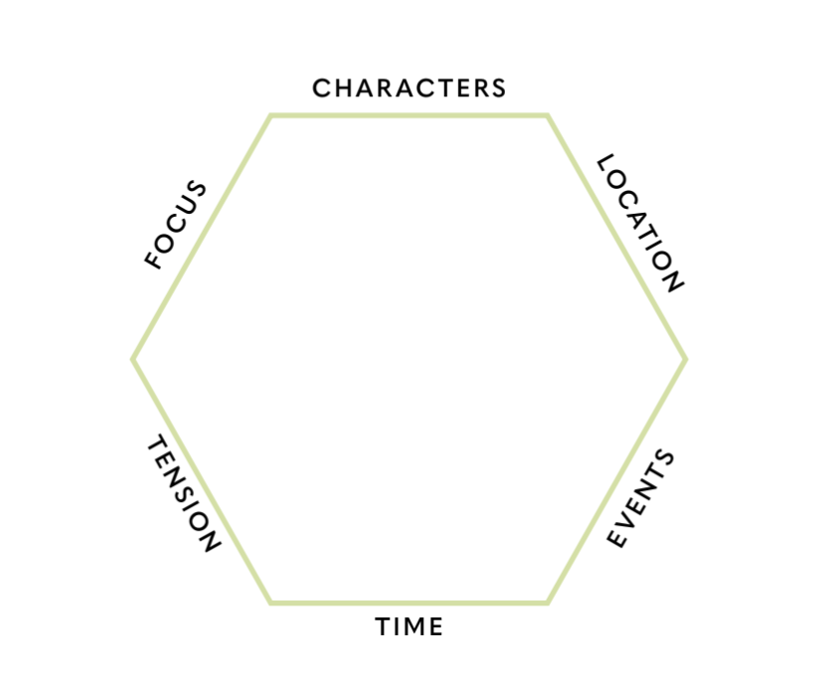

Characters:

Locations:

Events:

Time:

Tension:

Focus:

**You can use the hexagon to plan your context like this:**

1. Choose or invent a situation from a curriculum area you are looking to explore, or from a book, film or other medium that inspires you. Be creative!

2. Think of a moment in the situation that you think might engage the students and create an opportunity to develop the learning you have planned for them.

3. Fill in the details under the headings around the six sides of the shape. Make sure any invented ideas are relevant, historically accurate, culturally appropriate, and consistent with the rest of the situation. If in doubt, adjust the elements or change the context.